Games Programming 1 – Pipe Game

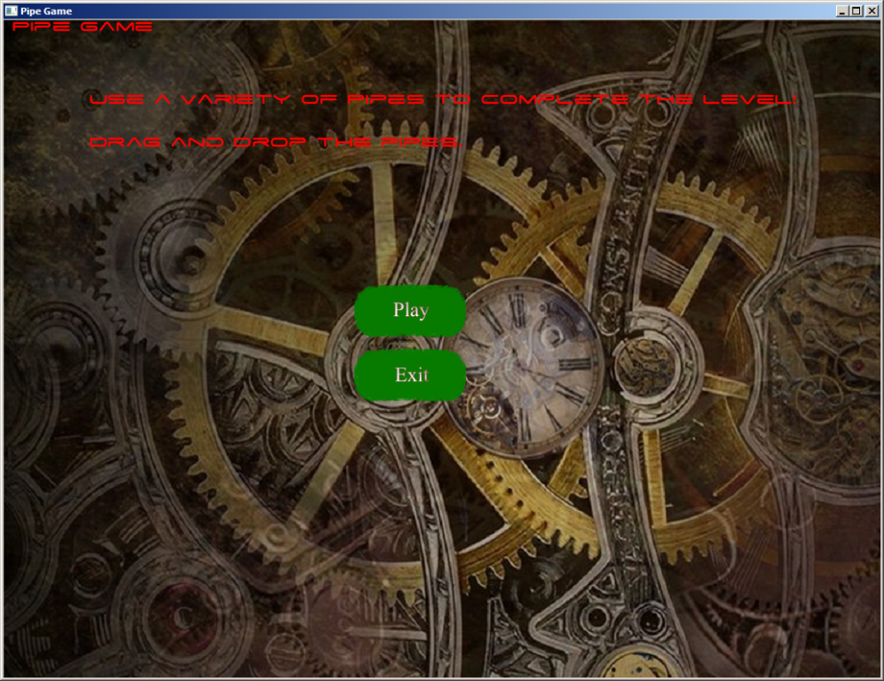 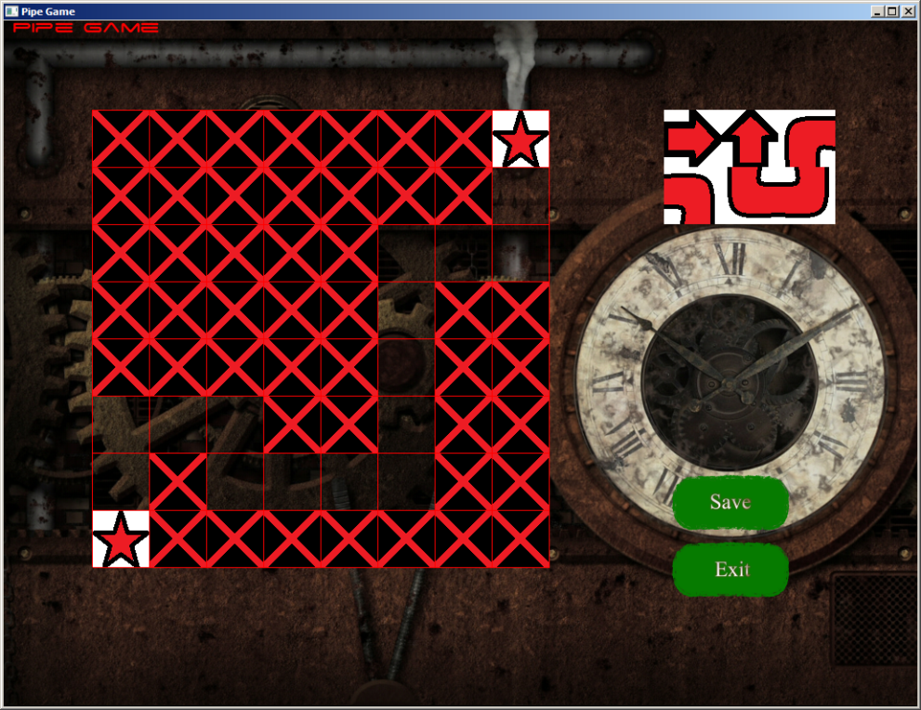

Sound Effects: None Sound Effects: None

Music: MenuMusic.wav Music: MainGame.wav

Interactions: Play Button, begins the main game. Exit Button, ends the program. Interactions: Save Button, saves the map to a text file. Exit Button, ends the program. 6 interactive tiles can be placed on the map.

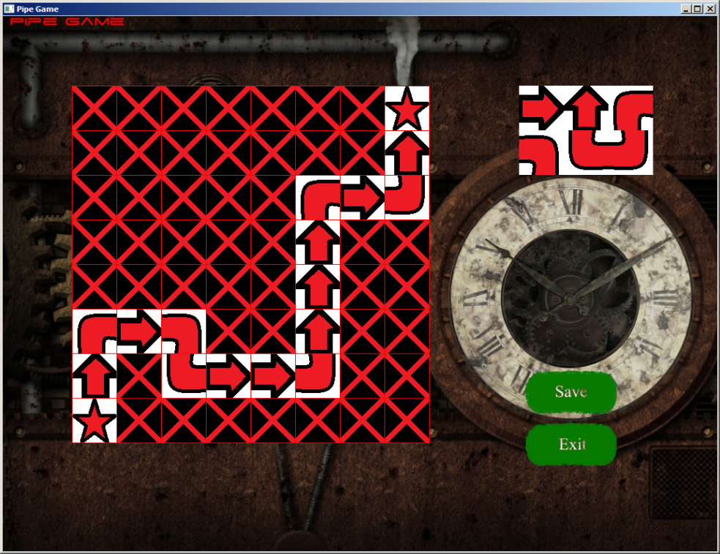 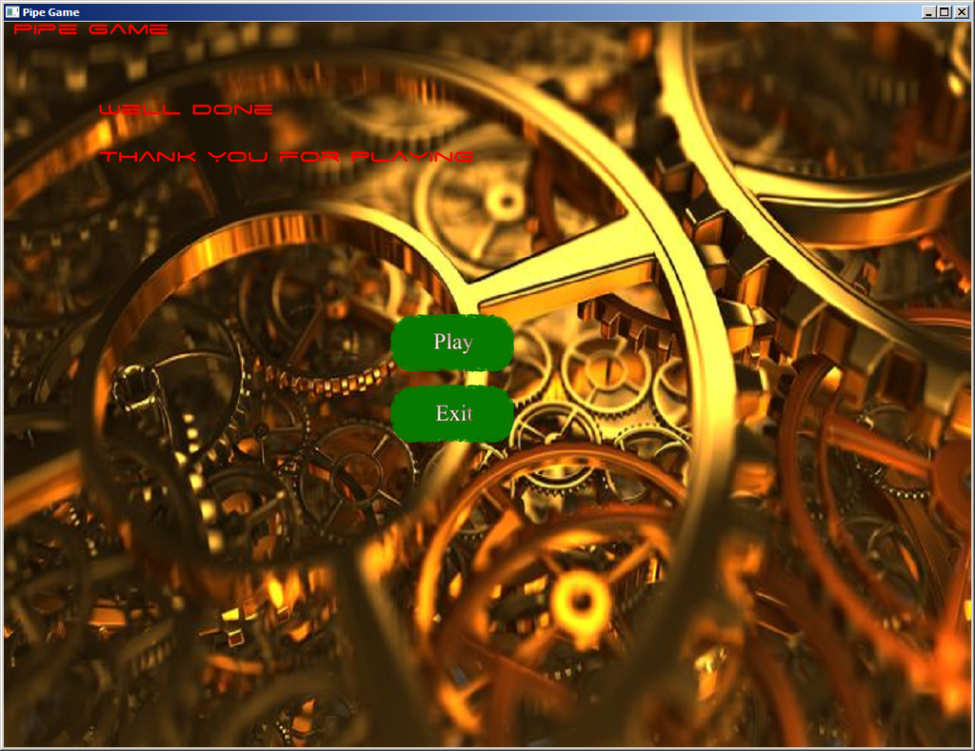

Sound Effects: None Sound Effects: None

Music: MainGame.wav Music: EndMusic.wav

Interactions: Save Button, saves the map to a text file. Exit Button, ends the program. Interactions: Play Button replays the level. Exit Button, ends the program